Embedded System: Homework Week 5
Type your answers straight into the empty table cells and answer bars below. Use only numbers you measured in week 5, in this room, or values you copied out of a datasheet with the page number written next to them.
Name | Student ID | Date
鄭宇峻 | NQ6141054 | 2026-10-19
Group number
Not applicable (no group assigned).
How to fill this in
- Every number should be your own or taken from the datasheet with the page number written next to it.
- If you couldn't get a value, leave the cell empty and write why. Don't guess.
- Write the unit with each number, and say where it came from (datasheet page, or the file or script that printed it).
- Each section ends with an optional box for screenshots: script output, plots, photos of your breadboard. Paste the image into the box and add a one-line caption.

1 · Who is on the bus (slide 11)
Scan the bus and record what answered. Then name the part and the datasheet you will use for the rest of this sheet.
Quantity | Your answer
Addresses that answered | 0x68 — w05/scan.txt
Number of devices answering | 1 — devices_answering=1
Therefore the part I have is | MPU6050 on the GY-521 module; scan 0x68 and WHO_AM_I=0x68 in fixed.txt.
Datasheet I am using (title and version) | InvenSense MPU-6000 and MPU-6050 Register Map and Descriptions, RM-MPU-6000A-00, Revision 4.2, 19 Aug 2013.

Discussion (section 1)
- Did anything answer that you did not expect?
No unexpected address answered. The saved scan contains only 0x68 and devices_answering=1; the later identity read returned WHO_AM_I=0x68.
Optional figures. For example: your scan output (scan.txt) as the serial monitor printed it.
Figures for section 1 (optional)
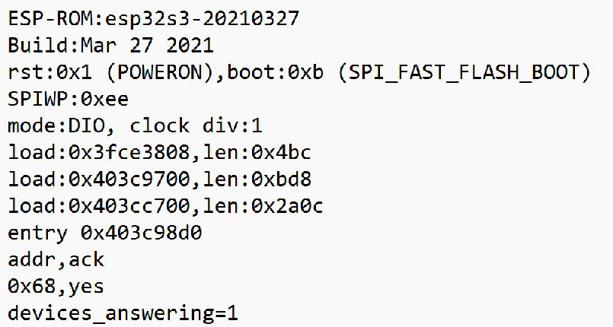
Figure 1. Original w05/scan.txt reopened in Notepad on 2026-10-19: one device answers at 0x68. Screenshot cropped to log content.

2 · Three buses, same six bytes (slide 18)
From bus_table.py.
Bus | Setting | Signal pins | kbit/s | kbit/s per pin | µs per 6-byte frame | Payload verified
I2C | 100 kHz | 2 | 52.6 | 26.3 | 911.8 | not checkable
I2C | 400 kHz | 2 | 179.5 | 89.8 | 267.3 | not checkable
SPI | 1 MHz | 4 | 763.9 | 191.0 | 62.8 | 12000/12000
SPI | 8 MHz | 4 | 3220.2 | 805.0 | 14.9 | 12000/12000
UART | 115200 → 115200 | 1 | 71.5 | 71.5 | 671.5 | 1200/1200
UART | 115200 → 125000 | 1 | 71.6 | 71.6 | 670.3 | 320/1200

Discussion (section 2)
- Which bus moved the most bits per signal pin, and by what factor over the worst?
SPI at 8 MHz was highest at 805.0 kbit/s per signal pin; I2C at 100 kHz was lowest at 26.3 kbit/s per pin. Using the displayed bus_table.py values, 805.0 / 26.3 ≈ 30.6 times.
- The UART rows use the same wire at the same speed. Only the far end's expectation changed. How many of the 1200 bytes survived the mismatched row?
320 of the 1200 bytes verified in the 115200 → 125000 row, or 26.7%; 880 did not verify. The matched row verified 1200/1200. The mismatched row’s 71.6 kbit/s describes the whole attempt, including receive time-outs.
- Why is the "payload verified" column empty for I2C and not for the other two?
I2C reads live IMU samples whose exact six-byte values are not known beforehand, so bytes_ok=-1 means the payload is not checkable. SPI and UART loopbacks send a known pattern and compare the received bytes with it.
Optional figures. For example: the bus_table.py output (buses.txt) with all six rows visible.
Figures for section 2 (optional)
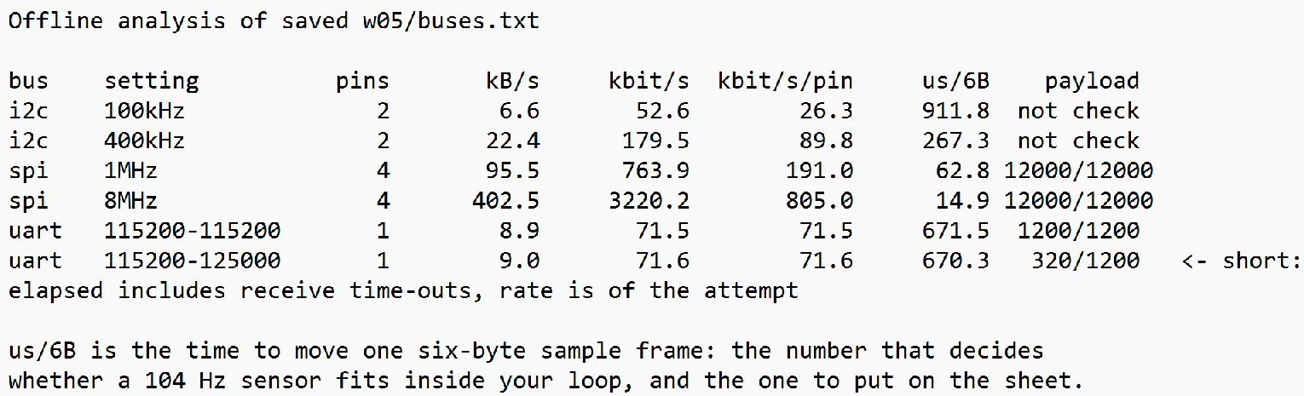
Figure 2. Actual bus_table.py output from saved w05/buses.txt, reopened in Notepad. All six rows and the UART timeout warning are visible; cropped screenshot.

3 · The four blanks (slide 28)
Fill these from the datasheet. Write the page or table number you found each one on. An answer with no page number is an answer you cannot defend.
Constant | Value | Found on page / table
WHOAMI_EXPECT | 0x68 | p. 45, §4.32: WHO_AM_I default is 0x68.
ACCEL_CFG_VALUE — ±4 g | 0x08 | p. 15, §4.5: AFS_SEL=01 in bits 4:3 selects ±4 g.
GYRO_CFG_VALUE — ±500 dps | 0x08 | p. 14, §4.4: FS_SEL=01 in bits 4:3 selects ±500 °/s.
XL_SENS_MG — mg/LSB at ±4 g | 0.1220703125 mg/LSB | p. 29, §4.17: 8192 LSB/g at ±4 g; 1000/8192 mg/LSB.
The full-scale field is two bits, so there are four codes. Write them out in the order the datasheet gives them.
Code 00 | Code 01 | Code 10 | Code 11
±2 g | ±4 g | ±8 g | ±16 g

Discussion (section 3)
- If that order surprised you, say so.
The register map lists 00 → ±2 g, 01 → ±4 g, 10 → ±8 g and 11 → ±16 g (p. 15, §4.5). Each step doubles the range; code 01 in bits 4:3 therefore gives the configuration byte 0x08.
Optional figures. For example: the datasheet table or page where you found each of the four values, with the page or table number visible.
Figures for section 3 (optional)
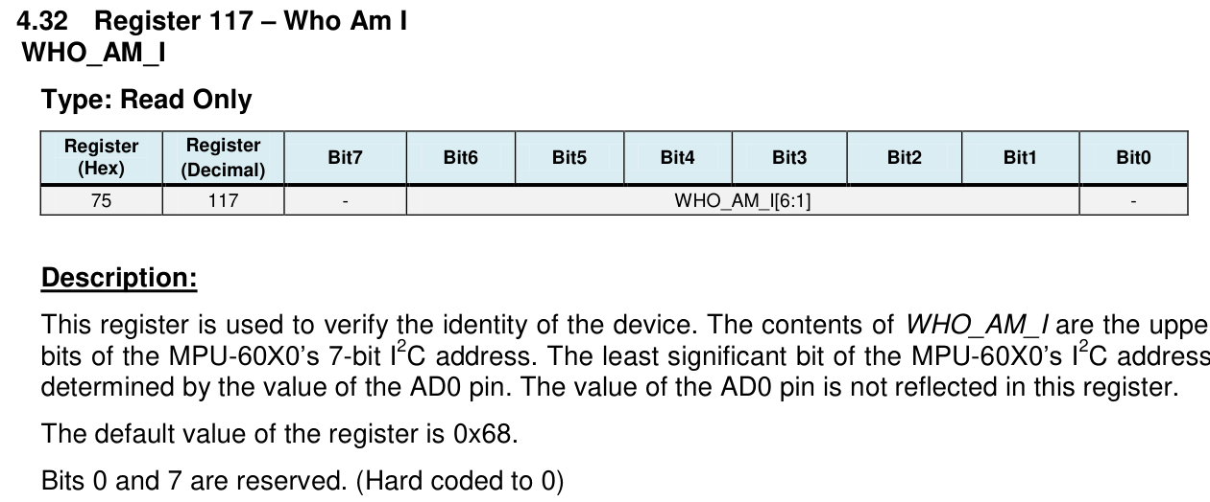
Figure 3a. Original Register Map rev. 4.2, p. 45, section 4.32: WHO_AM_I register 0x75 has default 0x68. PDF page excerpt.

Figures for section 3 (optional)
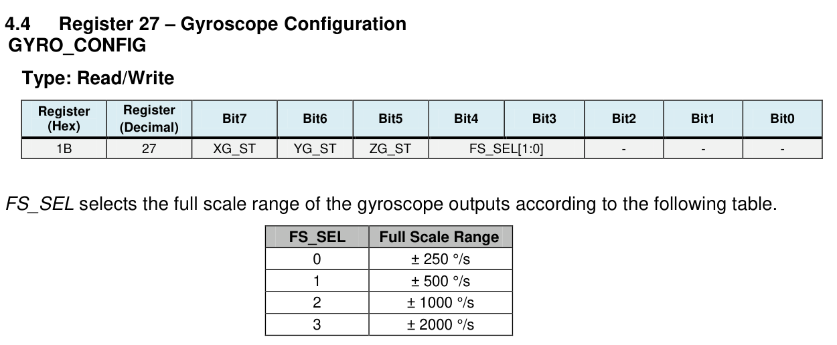
Figure 3b. Two excerpts from original p. 14, section 4.4: FS_SEL occupies bits 4:3; FS_SEL=1 selects +/-500 deg/s, giving configuration byte 0x08.

Figures for section 3 (optional)
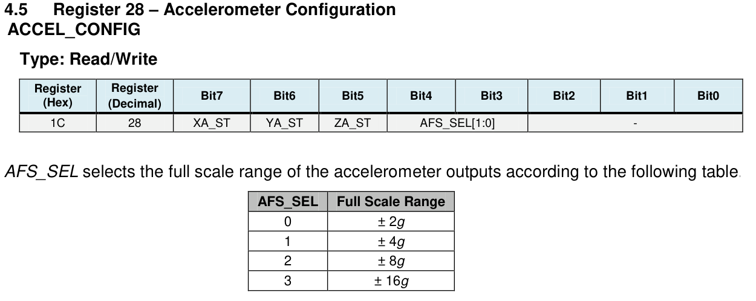
Figure 3c. Two excerpts from original p. 15, section 4.5: AFS_SEL occupies bits 4:3; AFS_SEL=1 selects +/-4 g, giving configuration byte 0x08.

Figures for section 3 (optional)
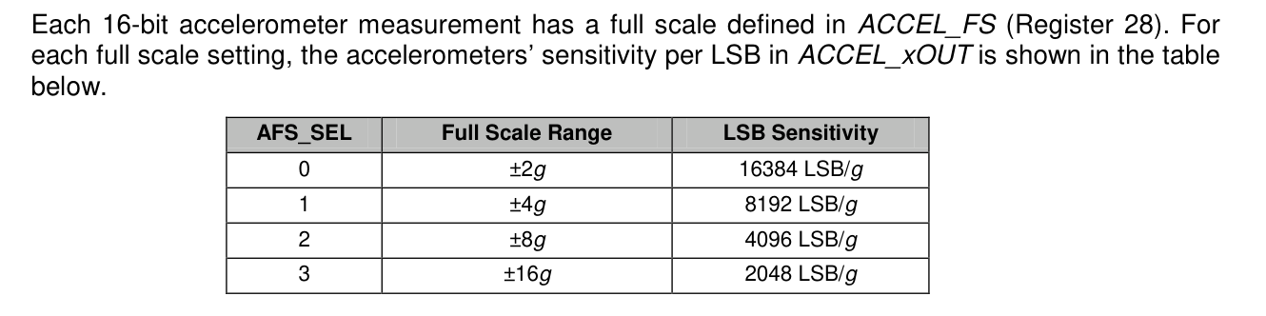
Figure 3d. Original p. 29, section 4.17: +/-4 g has sensitivity 8192 LSB/g, so 1000/8192 = 0.1220703125 mg/LSB. PDF page excerpt.

4 · The model's version against yours (slides 26, 31)
Fill both columns from the serial output of the two sketches. Read the definition of gap_us under the table before you compare the two numbers.
Quantity | Sketch 3 · the model | Sketch 4 · yours
who_am_i printed | 0x68 | 0x68; expected=0x68
Checked against the datasheet in code? | No; printed only | Yes; halts on mismatch
gap_us — see the definition below | 1 µs | 29,974 µs; settled=1
raw_z on frame 0 | 0 codes | 9,140 codes
g_z on frame 0 | 0.000 g | 1.116 g
raw_z on frame 5 | 0 codes | 9,190 codes
g_z on frame 5 | 0.000 g | 1.122 g

What gap_us measures, in both sketches and on the analyser. It opens at the STOP that ends the last configuration write and closes at the START of the first read of the output registers (0x3B). The data-ready polls of 0x3A in between are inside the window on all three accounts, so they cancel. Neither sketch reads a register back or prints anything inside that window — if it did, the two numbers would not be about the same span and subtracting them would mean nothing.

Discussion (section 4)
- Frame 0 and frame 5 came from the same device under the same configuration. If they differ, what happened between them, and how long did it take?
Sketch 3’s frames 0 and 5 both remained zero. In Sketch 4, five 1-second delays separate frame 0 from frame 5; raw_z changed from 9140 to 9190 (+50 codes, about +0.006 g). The device kept producing samples, but that small change alone does not establish motion.
- Your board is lying flat and still. Physics says one axis reads about 1 g. Which of the two sketches agrees with physics? If the other one is not zero, by what factor is it out? If it is zero, write that — zero is not a factor — and say which of Run 3's three causes you can now rule out, and on what evidence.
Sketch 4 agrees approximately with gravity: g_z was 1.116 g at frame 0 and 1.122 g at frame 5. Sketch 3 returned 0.000 g, so no finite multiplicative error factor can be assigned. An unsupported full-scale setting can be ruled out: the register map specifies 0x08 on pp. 14–15, and Sketch 4 read back cfg=0x08,0x08 and produced live data. Sketch 3’s cfg=0x00,0x00 and gap_us=1 do not isolate sleep from insufficient settling; its code omitted the wake-up write and ACK checks.
Optional figures. For example: the serial output of each sketch, with frames 0 and 5 visible.
Sketch 3 · the model (ai-init.txt) | Sketch 4 · yours (fixed.txt)
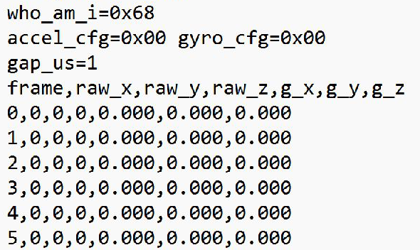  Figure 4a. Original ai-init.txt reopened: identity printed, cfg=0x00,0x00, gap_us=1 and frames 0-5 all zero. Cropped screenshot. | 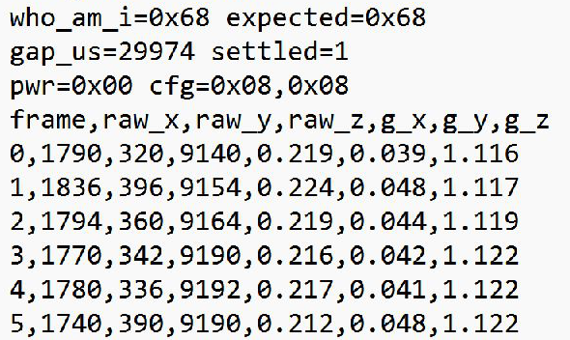  Figure 4b. Original fixed.txt reopened: checked identity, settled=1, correct readback and frames 0-5 with Z approximately 1 g. Cropped screenshot.

5 · The price of being correct (slide 33)
Check these against your own build output. This is the one pair of numbers the deck gives you, because the linker produced it, not your board. RAM comes out the same on every machine. Flash can differ by a few bytes from one machine to another, because the project path is compiled into the image — so the number to compare is the difference between the two sketches, which should not move.
Build | Flash (bytes) | RAM (bytes)
Sketch 3 · the model's init — deck | 283,925 | 18,760
Sketch 3 — yours | 283,877 | 18,760
Sketch 4 · your init — deck | 285,001 | 18,760
Sketch 4 — yours | 284,969 | 18,760
Difference between the two sketches, yours | 1,092 | 0
Build sketch 4 with your four blanks filled in. It should give the same figure either way — if it does not, say so, because that would mean the compiler threw one of the checks away and the number above is measuring the wrong program.
Build | Flash (bytes) | RAM (bytes)
Sketch 4 — before you filled the blanks | 284,969 | 18,760
Sketch 4 — with your four blanks filled in | 284,969 | 18,760
Same figure either way? If not, say so here:
Yes. Fresh local builds on 2026-10-15 gave the same 284,969 bytes Flash and 18,760 bytes RAM with the four blanks zero and with them filled. Sketch 4 therefore costs 284,969 − 283,877 = 1,092 extra Flash bytes and 0 extra RAM bytes against Sketch 3. This is 16 bytes above the deck’s 1,076-byte Flash difference; the reason for that difference has not been established. Build logs are saved in w05/.
Optional figures. For example: the Flash and RAM lines from each build output.
Figures for section 5 (optional)
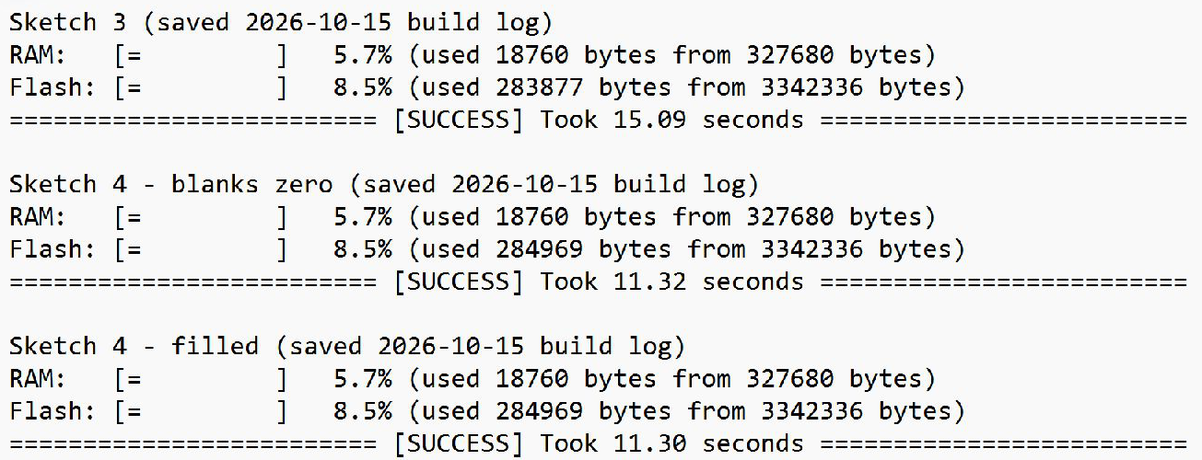
Figure 5. Screenshot of verbatim RAM, Flash and SUCCESS lines from the saved 2026-10-15 build logs: Sketch 3, Sketch 4 with zero blanks, and Sketch 4 filled. Only descriptive block labels were added.

6 · The transaction, byte by byte (slides 40, 42, 44)
Fill Observed afterwards, from your own capture. A prediction you write after seeing the answer is not a prediction, and it is obvious in the marking.
# | Field | Predicted | Observed | Agree?
1 | START | START | START | Yes
2 | address + R/W bit | 0xD0 (0x68 + write) | 0xD0 (7-bit 0x68, write) | Yes
3 | ACK / NACK | ACK from IMU | ACK from IMU | Yes
4 | register address | 0x75 (WHO_AM_I) | 0x75 (WHO_AM_I) | Yes
5 | ACK / NACK | ACK from IMU | ACK from IMU | Yes
6 | repeated START | repeated START | repeated START | Yes
7 | address + R/W bit | 0xD1 (0x68 + read) | 0xD1 (7-bit 0x68, read) | Yes
8 | ACK / NACK | ACK from IMU | ACK from IMU | Yes
9 | data byte | 0x68 | 0x68 | Yes
10 | ACK / NACK | NACK from controller | NACK from controller (final byte) | Yes
11 | STOP | STOP | STOP | Yes
Address and clock. Write both addresses, and read the SCL period off the analyser cursors.
Quantity | Your value | Unit
Address your scan printed (section 1) | 0x68 | 7-bit address
Address byte on the wire (from your capture) | 0xD0 (write); 0xD1 (read) | 8-bit byte including R/W
Measured SCL period from the analyser cursors | 10.0 | µs
The same period as a frequency | 100.0 | kHz
Clock you asked for | 100 | kHz

Discussion (section 6)
- Any field where prediction and observation disagree is the most interesting line on this sheet. Say which one and what you concluded.
All eleven predicted fields agree with the physical FX2 capture. The on-wire bytes were D0, 75, D1 and 68, with the predicted ACK/NACK and repeated START. The complete transaction lasted 408.0 us, compared with 360 us for the 36 clock periods; edge conditions and pauses account for the remainder.
- The address byte on the wire is not the number your scan printed. You wrote both in the table above; explain the relationship in one line.
Verified from the capture: byte = (0x68 << 1) | R/W, giving 0xD0 for write and 0xD1 for read. PulseView displays the 7-bit value 0x68 and labels the write/read direction separately.
- You asked for 100 kHz. Is the difference from your measured SCL frequency inside or outside what you would accept, and why?
PulseView cursors at 2.347412 s and 2.347422 s bracket consecutive SCL rising edges: 10.0 us, or 100.0 kHz. This agrees with the requested 100 kHz at the 0.5 us sample resolution of the 2 MHz capture; it does not establish zero frequency error.
- Graded, 3 marks. If SDA and SCL were swapped in the wiring itself, what would the analyser show, and why? Answer in terms of which line carries timing and which carries data. "It would break" is not an answer; neither is "the signal gets slower".
With the physical SDA/SCL connections crossed, GPIO9 would still carry the controller’s clock and GPIO8 its data, but the IMU would receive the clock on SDA and data transitions on SCL. The intended timing/data relationship would be wrong at the IMU, so I would expect no valid device ACK or reply. The analyser should show the controller’s attempted transaction with an absent ACK, rather than a normally decoded exchange.
Optional figures. For example: your decoded I2C transaction and the analyser cursors you used to measure the SCL period.
Decoded I2C capture and SCL period measurement
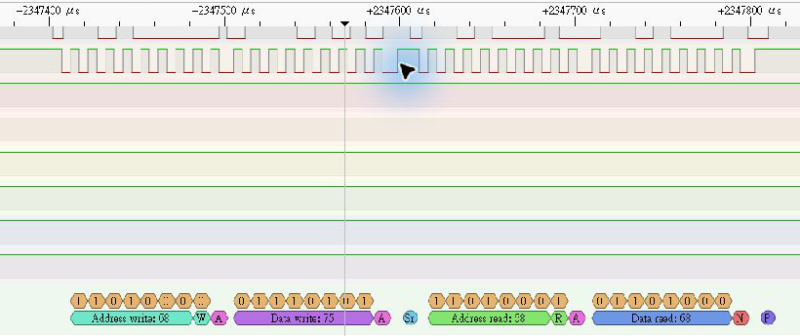
Figure 6a. Physical WHO_AM_I read: address 0x68 write, register 0x75, repeated START, address 0x68 read, data 0x68 and final NACK/STOP. PulseView screenshot cropped for readability; full original: w05/whoami-capture.png.
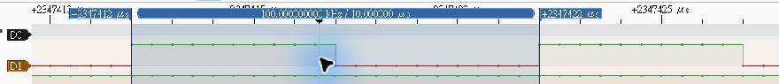
Figure 6b. PulseView cursors on consecutive SCL rising edges: 2.347412 s to 2.347422 s, delta 10.0 us / 100.0 kHz. Full original: w05/scl-period-cursors.png.

7 · The cross-check (slide 46)
From crosscheck.py.
Quantity | Your value | Unit
gap_us — the board's own micros() | 29,974 | µs
the same gap measured on the analyser | 30,028 | µs
difference | +54 | µs
difference as % of the board's number | +0.18 | %
the script's verdict — AGREE / DISAGREE / NO VERDICT | AGREE, within the stated tolerance.
If it printed NO VERDICT, write down which precondition it named and what you would have to change to get past it. That is a complete answer to this section; an agreement between two numbers that were never measurements is not.
If the verdict was NO VERDICT | Your answer
Which precondition it named | Not applicable: the script printed AGREE; no NO VERDICT refusal was printed.
What you would have to change to get past it | No remedial change was required. Identity matched 0x68, settled=1, no halt occurred, and both measured intervals were positive. The stated tolerance was unchanged.

Discussion (section 7)
- In W03 you timed the chip with the chip and we said nobody was checking the referee. Somebody is now. Write one sentence saying what today's two numbers let you claim that W03's single number did not.
A separate FX2 clock measured 30,028 us against the same-reset ESP32 value of 29,974 us, a +54 us (+0.18%) difference inside the unchanged 599.5 us tolerance; this supports the timing of this interval independently of the board, without establishing absolute accuracy or sensor calibration.
Capture method: Capture on 2026-10-19 used the physical FX2 at 2 MHz (5 s, 10 million samples), with a matching COM6 serial log. Native PulseView opening failed; an isolated official libusb 1.0.30 asynchronous reader acquired the samples, which PulseView then decoded (SDA=D0, SCL=D1). Codex located edge sample positions and placed the PulseView cursors there; the displayed readouts were checked. The gap opens at final INT_ENABLE-write STOP (sample 4,698,724) and closes at first 0x3B-read START (sample 4,758,780), including the intervening 0x3A poll. The captured first acceleration frame matches the same-reset serial frame. This uses an independent instrument, not VIMU self-reporting.
Optional figures. For example: the crosscheck.py output, and the analyser cursors on the gap_us window. Do not crop out a NO VERDICT line.
Crosscheck output and analyser cursors on the measured interval
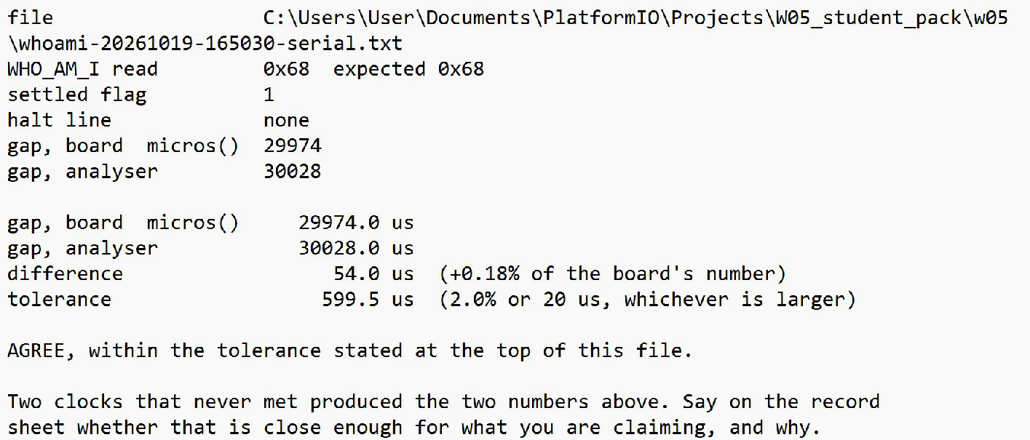
Figure 7a. Saved crosscheck.py stdout reopened in Notepad, including the input log path and complete AGREE verdict. Same-reset values: board 29974 us, analyser 30028 us, difference +54 us (+0.18%). Cropped screenshot.
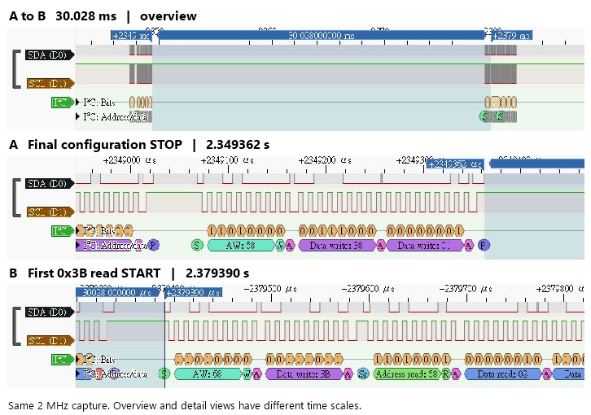
Figure 7b. Three cropped PulseView screenshots of the same capture: overview and endpoint zooms. A = final 0x38=0x01 configuration STOP (2.349362 s); B = first 0x3B-read START (2.379390 s). B-A = 30.028 ms = 30028 us. D0=SDA, D1=SCL; time scales differ. Full screenshots are in w05/figures/.

8 · What you can actually get off the bus (slide 48)
From Sketch 6.
Run | Clock | delay per read | reads/s
1 | 100 kHz | 0 ms | 1096.0
2 | 400 kHz | 0 ms | 3727.0
3 | 400 kHz | 1 ms | 1000.0

Discussion (section 8)
- You want 104 six-byte frames a second. Does each of these three runs clear that bar?
Yes. The three successful bus-read rates were 1096.0, 3727.0 and 1000.0 reads/s, all above 104 six-byte frames/s. Each row in stream.txt has failed=0.
- Run 2 and run 3 differ by one delay(1). What did that one line cost you, as a factor? Write the division, not just the answer.
3727.0 / 1000.0 = 3.727, so adding delay(1) reduced the bus-read rate by about 3.73 times. The reduction was 2727 successful reads/s.
- Now the harder half: the Register Map (§4.2, p. 12) says the accelerometer's output rate is 1 kHz. Given that, how many new samples did the delay(1) actually lose you? What does your answer to (b) therefore mean?
The register map states a 1 kHz accelerometer output rate (p. 12, §4.2), so at most 1000 fresh samples exist per second. In ideal rate accounting, the 1000 reads/s delayed run need not lose any fresh samples; the faster 3727 reads/s run mainly rereads existing samples. The log does not track sample identities or data-ready events, so an exact zero loss was not measured; the 3.727 factor is a bus-throughput comparison.
Optional figures. For example: the Sketch 6 stream-rate output for all three runs (stream.txt).
Figures for section 8 (optional)
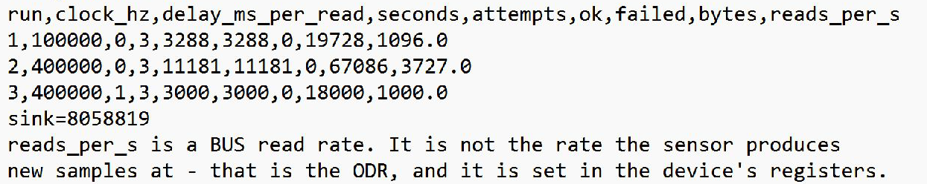
Figure 8. Original w05/stream.txt reopened in Notepad: all three rows have failed=0 and rates 1096.0, 3727.0 and 1000.0 reads/s. The original bus-rate/ODR note is retained. Cropped screenshot.

